3x3 NMOS Transistor Multiplier

By Ian Lane

## **Purpose**

This project is being created during my Junior year at UMBC while taking CMPE 314, Principles of Electronic Circuits. In this class we have learned about the fundamentals of BJT and MOSFET transistors and how to use them under AC analysis to create AC amplifiers. My goal for this project is to take the fundamental knowledge I have learned from my class and rather than use them under AC conditions as I have already done, instead using MOSFETs in particular, use them under DC conditions such that I can use them as logical switches that can be used in VLSI.

## **The 3 x 3 multiplier**

The 3 x 3 multiplier is unfortunately not one that is most likely ever going to be used in any VLSI design because of it only being able to handle numbers 0 through 7, however there are reasons as to why I decided to choose this over anything else.

First off, why not a simpler binary adder that can handle twice as many bits? The reason I chose to design a multiplier over an adder is because the logic required for the multiplier is more complex than that of an adder. A multiplier is essentially a multistep adder which requires more logic to handle and I not only wanted to test my knowledge and understanding of MOSFETs, but also to come up with a design, schematic, and implementation that required more problem solving.

Since I have decided I wanted to create a multiplier, why choose a 3x3 and not a 4x4 or 2x2 etc? Firstly anything smaller than a 3x3 bit multiplier has too simple of logic, even a 10x2 multiplier is essentially just a 10 bit adder and I wanted to create something more complex than that. However on the other side of things a 4x4 multiplier requires significantly more logic that a 3x3. I was originally going to create the 4x4 bit multiplier for a more significant range of numbers, however once I realized how much more logic was required I decided it was not a good idea. The main reason I decided this was not because the logic was difficult, but because of how many more transistors it would require to create. I wanted to stay within the roughly 100 transistor mark because that is all the transistors that I have. Also because I have a limited number of breadboards to be used on this project. A basic breadboard has 2 separate 62 line channels on, since every transistor has 3 terminals, it means that an absolute maximum number of transistors on one breadboard is 41, meaning I will need at least 3 breadboards just for 100 transistors. So with my constraints the 3x3 multiplier using roughly 112 transistors is the smallest multiplier I am going to create.

This multiplier is going to be made entirely out of 2n7000 MOSFETs. My original goal was to create the multiplier out of both n and p channel MOSFETs to create a stable CMOS equivalent, however the first problem with this is that it would double the space that would need to be required from a minimum of three to six breadboards for full scale. The second major problem is that I could not find a substantial quantity of PMOS transistors, and those that I could find already cost more than the NMOS transistors for a tenth of the quantity.

## **Logic/Basic Concept**

### Table 1

|  |  |  |  | A3 | A2 | A1 |
| --- | --- | --- | --- | --- | --- | --- |
|  |  |  | x | B3 | B2 | B1 |
|  |  |  |  | A3B1 | A2B2 | A1B1 |
| + |  | C4 | A3B2 | A2B2 | A1B2 | 0 |
| + |  | A3B3 | A2B3 | A1B3 | 0 | 0 |
| + | C5 | C3.2 | C3.1 | C2 | 0 | 0 |
|  | D6 | D5 | D4 | D3 | D2 | D1 |

This table shows the multiplication process of any two, three bit numbers. Each cell in the table containing data except for the operands “+” and “x” represent either a logical 1 or 0.

A3-A1 represents the logical bits of the first expression with A1 being the least significant bit (LSB).

B3-B1 represents the logical bits of the second expression with B1 being the LSB.

D6-D1 represents the logical bits of the answer where D1 is the LSB.

Any bit containing a “C” represents a carry bit, the number after the C indicates which column the carry bit is coming from. For example C2 is the carry bit from adding A2B1 and A1B2 from column 2. Notice that two of the carry bits, C3.1 and C3.2 both come from column 3, but represent different carries which will be discussed later.

Any bits labeled with an A and a B, for example A1B1, represent the logical AND of bits A1 and B1. When multiplying in binary any number times 0 gives an answer of 0, so the only way the bit can be a 1 is if both bits are 1, and therefore you logically AND them together to get the correct answer for each bit.

### Logic Expressions

#### Answer bits

D1 = A1B1

D2 = A2B1 A1B2

D3 = A3B1 A2B2 C2

D4 = A3B2 A2B3 C3.1

D5 = A3B3 C4 C3.2

D6 = C5

The answer bits for this is quite easy as we simply XOR each bit in each column, which is the equivalent of adding them all together.

#### Carry Bits

C2 = A2B1 A1B2

C3.1 = (A3B1 + A2B2 + A1B3 + C2) ~(A3B1  A2B2 A1B3 C2) ~(~A3B1  ~A2B2 ~A1B3 C2) ~(~A3B1  ~A2B2 A1B3 ~ C2) ~(~A3B1  A2B2 ~A1B3 ~C2) ~(A3B1  ~A2B2 ~A1B3 ~C2)

C3.2 = (A3B1  A2B2 A1B3 C2)

C4 = ~(~C3.2 + ~(A3B2 + A2B3)) + ~(C3.2 + ~(A3B2  A2B3))

C5 = ~(~A3B3 + ~(C4 + C3.2)) + ~(A3B3 + ~(C4  C3.2))

The difference between C3.1  and C3.2 is that C3.2  is a double carry whereas C3.1  is a single carry. If all four bits in column three are a 1, then two carries need to be implemented. One way to do this would be to add both of those carries into column four, however I ran into the same problem of another possible double carry in column four, so in order to reduce the logic, and therefore reduce the number of transistors, needed then if all four bits in column four are a 1, then we add only one carry to column 5, and C3.1 would be a 0. C3.1 and C3.2 can both be 0 but can never both be 1.

### Truth tables

C2

| A2B1 | A1B2 | C2 |
| --- | --- | --- |
| 0 | 0 | 0 |
| 0 | 1 | 0 |
| 1 | 0 | 0 |
| 1 | 1 | 1 |

C3.1

| A3B1 | A2B2 | A1B3 | C2 | C3.1 |
| --- | --- | --- | --- | --- |
| 0 | 0 | 0 | 0 | 0 |
| 0 | 0 | 0 | 1 | 0 |
| 0 | 0 | 1 | 0 | 0 |
| 0 | 0 | 1 | 1 | 1 |
| 0 | 1 | 0 | 0 | 0 |
| 0 | 1 | 0 | 1 | 1 |
| 0 | 1 | 1 | 0 | 1 |
| 0 | 1 | 1 | 1 | 1 |
| 1 | 0 | 0 | 0 | 0 |
| 1 | 0 | 0 | 1 | 1 |
| 1 | 0 | 1 | 0 | 1 |
| 1 | 0 | 1 | 1 | 1 |
| 1 | 1 | 0 | 0 | 1 |
| 1 | 1 | 0 | 1 | 1 |
| 1 | 1 | 1 | 0 | 1 |
| 1 | 1 | 1 | 1 | 0 |

C3.2

| A3B1 | A2B2 | A1B3 | C2 | C3.2 |
| --- | --- | --- | --- | --- |
| 0 | 0 | 0 | 0 | 0 |
| 0 | 0 | 0 | 1 | 0 |
| 0 | 0 | 1 | 0 | 0 |
| 0 | 0 | 1 | 1 | 0 |
| 0 | 1 | 0 | 0 | 0 |
| 0 | 1 | 0 | 1 | 0 |
| 0 | 1 | 1 | 0 | 0 |
| 0 | 1 | 1 | 1 | 0 |
| 1 | 0 | 0 | 0 | 0 |
| 1 | 0 | 0 | 1 | 0 |
| 1 | 0 | 1 | 0 | 0 |
| 1 | 0 | 1 | 1 | 0 |
| 1 | 1 | 0 | 0 | 0 |
| 1 | 1 | 0 | 1 | 0 |
| 1 | 1 | 1 | 0 | 0 |
| 1 | 1 | 1 | 1 | 1 |

C4

| A3B2 | A2B3 | C3.2 | C4 |
| --- | --- | --- | --- |
| 0 | 0 | 0 | 0 |
| 0 | 0 | 1 | 0 |
| 0 | 1 | 0 | 0 |
| 0 | 1 | 1 | 1 |
| 1 | 0 | 0 | 0 |
| 1 | 0 | 1 | 1 |
| 1 | 1 | 0 | 1 |
| 1 | 1 | 1 | 1 |

C5

| A3B3 | C3.2 | C4 | C5 |
| --- | --- | --- | --- |
| 0 | 0 | 0 | 0 |
| 0 | 0 | 1 | 0 |
| 0 | 1 | 0 | 0 |
| 0 | 1 | 1 | 1 |
| 1 | 0 | 0 | 0 |
| 1 | 0 | 1 | 1 |
| 1 | 1 | 0 | 1 |
| 1 | 1 | 1 | 1 |

## **Schematic/Design**

<https://github.com/ianlane1/3x3MOSFETMultiplier> This link will bring you to a github containing the schematic that I have created for this project.

**Important notice:** In the full scale design on the breadboards I am using the 2N7000 n channel MOSFET, however LTspice does not have that specific model of MOSFET so instead I am using the 2N7002 in the schematic design as a replacement, however both MOSFETs are the same.

In the file called NMOS Logic.asc is a schematic going over the basic logic gates and how they are created using NMOS transistors. You can download the .asc file and switch the different voltages of each component and see how it affects the voltage of the net you are looking at.

**Logical AND**

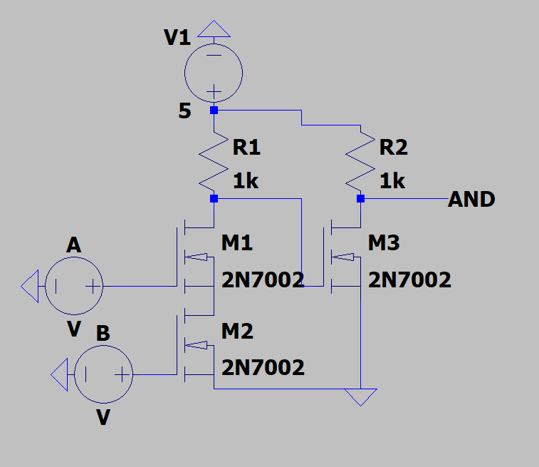

In this picture you can see the schematic design of the two input AND. The first two transistors M1 and M2 are the NAND of voltage source A and B and then transistor M3 inverts the signal into an AND. In order to increase the number of inputs to this and just add however many transistors you need in series with M1 and M2 and ensure they have their own voltages at the gates.

**Logical OR**

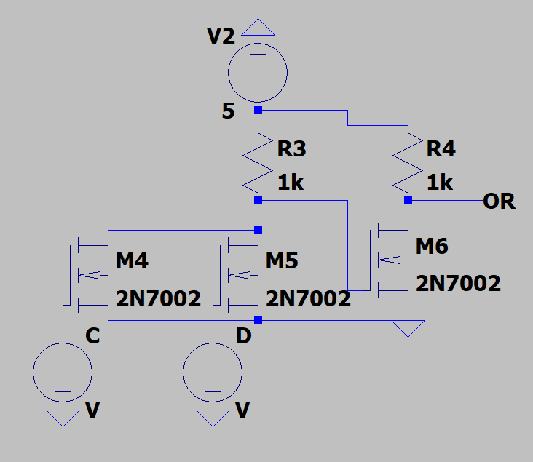

This picture shows the schematic of a two input logical OR gate. Transistors M4 and M5 give the output of the logical NOR whereas M6 inverts that signal to give the logical OR. In order to increase the number of inputs into this schematic you would put however many more transistors needed in parallel with M4 and M5 and give them their own gate signals.

**Important notice:** Whenever two signals are put into an AND the logical inverse of that signal is also given based on the creation of the AND, so when the signal A1B1, for example, is created I also have access to ~A1B1 without needing any more transistors. This means that for any logic in the Logical Expressions section, it has no effect whether the bit AnBm or Cn is used or the logical inverse. However, DeMorgans theorem is used to reduce the logical expression created with those bits in order to reduce transistors, as logical NANDs and NORs will use one less transistor than their respective inverses.

**Logical XOR**

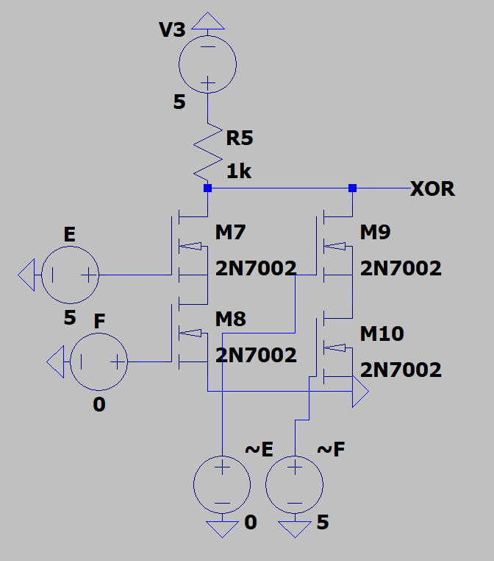

This picture shows the schematic of the final logical expression used in this project, the XOR. XOR only produces a logical 1 when only one voltage source E or F is 5 volts. The inverse of voltage sources E and F are also needed to make the XOR work and these are automatically created when doing ANDs or ORs. When doing multiple XORs as is done for most of the answer bits, it is more simple and takes less transistors to simply chain multiple XORs together. In order to XOR three inputs A, B, and C, to create a three input XOR would take 16 transistors. However when chaining XORs I XOR inputs A and B, and then take that output and XOR it with C, this only takes nine transistors, four for each individual XOR and one for the inverse of the first XOR.

Note that when trying out the schematic above ~E and ~F must be the logical inverse of E and F respectively otherwise the XOR will not work. Also XNOR is not used in this project explicitly, however if it would need to be created all that would need to be changed would be switching either F and ~E, or E and ~F.

**Full Scale Design**

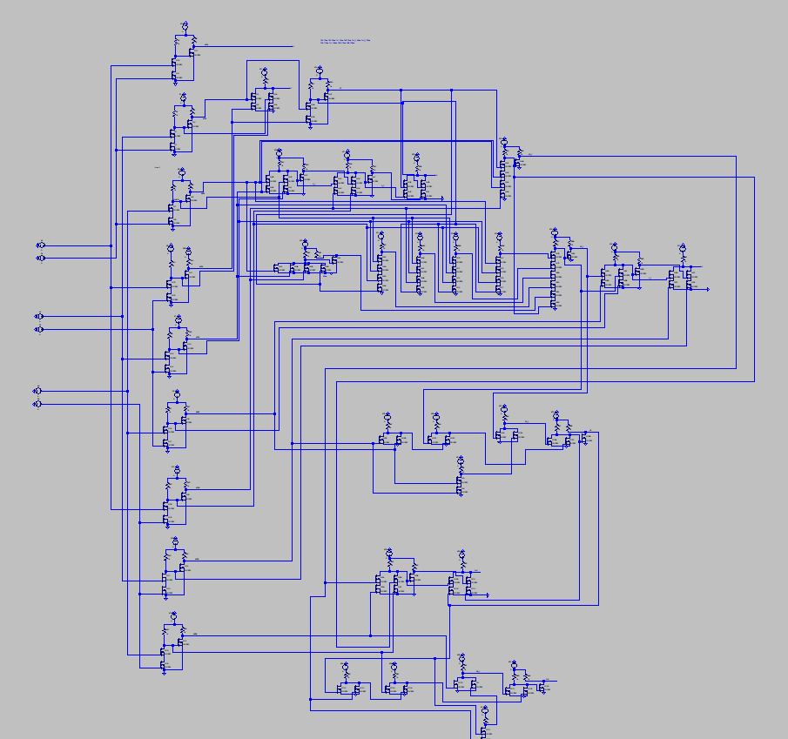

This picture shows the broad overview of the schematic. On the far left are the six voltages sources representing the 3 binary bits in A3-A1 and B3-B1. The top two voltage sources are A1 and B1 and then A2 and B2 and so on.

After the voltage sources are nine logical ANDs for each bit AnBm. After that I have set up blocks containing the answer and carry bits for each column. Each net labeled with a “C” is a carry bit and each net labeled with a D represents an answer bit. When conducting multiplication, any net with a 5V output represents a logical 1 and any net within the milliVolt range represents a logical 0. I would highly recommend for anyone interested to download the schematic in order to properly test and trace wire connections.

## **Timing Characteristics**

The data sheet of the 2N7000 claims that the max time from when the transistor sees a valid input and gives out a valid output is 10ns. The table below was calculated by taking the max input time of all the inputs into a logic gate and then adding 10ns for each transistor until we get an output.

| Node | Time (ns) |
| --- | --- |
| D1 | 20 |
| D2 | 30 |
| D3 | 70 |
| D4 | 120 |
| D5 | 170 |
| D6 | 190 |
| C2 | 40 |
| C3.1 | 60 |
| C3.2 | 90 |
| C4 | 160 |

The reason that these increase as such is because each carry builds off of the previous carry and so it must wait until the previous carry is finished so that it can have valid data. Therefore the total time that must be waited until the full answer is received is 190ns.

## **Code Analysis**

In order to fully test the full scale experiment I will be doing two things. The first will be manually inputting a few inputs and determining that the outputs are correct. This will be to ensure that most connections are secure and working before doing a full scale test.

In the full scale test I will be using an Arduino ATmega2560 that will send data in terms of 5 volts at the inputs A1-A3 and B1-B3 and then it will read data from nodes D1-D6. The Arduino will then compare the answer from the transistors with the answer it does based on its own calculations and a message will appear saying whether or not the test has passed or has failed.

The code can either be found through this link or through the github link in the Schematic/Design section

<https://docs.google.com/document/d/1_CTK3dWRzgG-Gu-3iEnMvZWZGH5hBHrFmo_N65WhYi8/edit?usp=sharing>

## **Full Scale Testing**

Currently no full scale testing has been done because I do not have the parts to do so. However I should be getting the parts to complete this around 12/25/2024 and so after that I will finish creating this and be uploading videos and pictures to this document as well as github.